Lab Report Number

Operating System


Submitted to:
Mam Syeda Aimal Fatima Naqvi

Submitted By:

Fatima Noor | 23-CyS-001
Muqaddas Asghar | 23-CyS-062
Zoya Husnain | 23-CyS-026

Dated:
June 6 , 2025

Department of Cyber Security
HITEC University, Taxila
LAB PROJECT

Dynamic multi-functional Operating System simulation:

Introduction:
This project is about building a simulation of an operating system that includes key features found in real OS environments. The goal is to cover important topics such as hybrid CPU scheduling, deadlock detection and avoidance, inter-process communication (IPC), memory management, and performance evaluation. The simulation helps us understand how these parts work together to manage multiple processes efficiently, fairly, and securely.

Literature Review:
To design the simulation, we studied various traditional and modern techniques used in operating systems. For process scheduling, we looked at common algorithms like First-Come-First-Serve (FCFS), Shortest Job First (SJF), Round Robin (RR), and Priority Scheduling. We also explored more dynamic scheduling approaches that adjust based on system conditions.
In terms of deadlock handling, we reviewed the Banker's Algorithm for avoiding unsafe states and also learned how to detect deadlocks using wait-for graphs. For IPC, we looked at message passing and shared memory, both of which are commonly used to allow communication between processes. Memory management concepts like paging and segmentation were also studied to understand how memory is organized and allocated.

Methodology and Design:

Hybrid CPU Scheduling
Our simulation uses a hybrid scheduling approach. It switches between Round Robin and Priority Scheduling depending on the current system load and if any process is at risk of starvation. This way, we aim to balance responsiveness and fairness while keeping CPU usage high.

Deadlock Detection and Avoidance
We used a wait-for graph to detect deadlocks during runtime. For prevention, we applied the Banker's Algorithm, which checks if granting a resource request would lead to an unsafe state. If not safe, the request is delayed. This ensures that processes don’t get stuck in circular wait conditions.

Inter-Process Communication (IPC)
For IPC, we implemented both shared memory and message queues to let processes communicate. Mutex locks are added to make sure that shared data isn’t accessed by multiple processes at the same time, preventing race conditions and data inconsistency.

Memory Management
We used paging to simulate how operating systems allocate and manage memory. Each process is assigned pages, which are then mapped to available memory frames. The simulation also includes page replacement policies like FIFO (First-In-First-Out) and LRU (Least Recently Used) to handle full memory conditions.

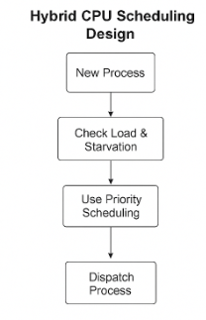
Figure 1: Hybrid CPU Scheduling Design
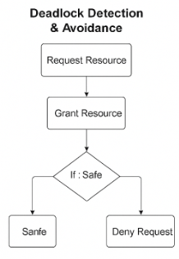
Figure 2: Deadlock Detection & Avoidance
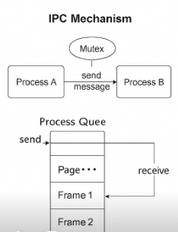
Figure 3: IPC Mechanism
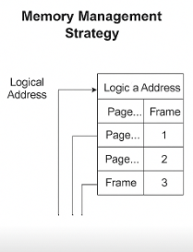
Figure 4: Memory Management

Code:
import queue
# Process class to hold process info
class Process:
def __init__(self, pid, arrival, burst, priority, max_resources):
self.pid = pid
self.arrival = arrival
self.burst = burst
self.remaining = burst
self.priority = priority
self.max_resources = max_resources
self.allocated = [0] * len(max_resources)
self.finished = False

# Simulated processes
process_list = [
Process(1, 0, 6, 2, [5, 3]),
Process(2, 1, 8, 1, [3, 2]),
Process(3, 2, 7, 3, [4, 2])
]

available_resources = [7, 5]
time_quantum = 3

# Scheduler: Hybrid Round Robin + Priority
def hybrid_scheduler(processes):
ready_queue = queue.Queue()
time = 0
processes.sort(key=lambda p: (p.arrival, p.priority))
while any(p.remaining > 0 for p in processes):
for p in processes:
if p.arrival <= time and p.remaining > 0 and p not in list(ready_queue.queue):
ready_queue.put(p)

if ready_queue.empty():
time += 1
continue

current = ready_queue.get()
exec_time = min(current.remaining, time_quantum if time % 2 == 0 else current.remaining)
print(f"Time {time}-{time + exec_time}: Process {current.pid} executed")
current.remaining -= exec_time
time += exec_time

if current.remaining > 0:
ready_queue.put(current)

# Deadlock Detection using Wait-for Graph
def detect_deadlock(processes):
wait_for = {p.pid: [] for p in processes}
for p in processes:
for i, need in enumerate(p.max_resources):
if need > available_resources[i]:
wait_for[p.pid].append((i, need))

deadlocked = [pid for pid, needs in wait_for.items() if needs]
if deadlocked:
print("Deadlock detected among processes:", deadlocked)
else:
print("No deadlock detected.")

# Banker's Algorithm for Deadlock Avoidance
def is_safe(processes, available):
work = available[:]
finish = [False] * len(processes)

while True:
found = False
for i, p in enumerate(processes):
need = [p.max_resources[j] - p.allocated[j] for j in range(len(available))]
if not finish[i] and all(need[j] <= work[j] for j in range(len(available))):
for j in range(len(available)):
work[j] += p.allocated[j]
finish[i] = True
found = True
if not found:
break

return all(finish)

# Inter-Process Communication using Queues
ipc_queue = queue.Queue()

def send_message(sender, receiver, message):
print(f"Process {sender} sending message to Process {receiver}")
ipc_queue.put((receiver, message))

def receive_message(receiver):
while not ipc_queue.empty():
pid, msg = ipc_queue.get()
if pid == receiver:
print(f"Process {receiver} received message: {msg}")
return

# Memory Management with Paging (FIFO replacement)
memory_size = 3
memory = []

def access_page(pid, page):
global memory
if page in memory:
print(f"Process {pid} accessed page {page} (in memory)")
else:
if len(memory) >= memory_size:
removed = memory.pop(0)
print(f"Page {removed} removed from memory")
memory.append(page)
print(f"Process {pid} loaded page {page} into memory")

# Main simulation
print("---- Hybrid Scheduling Simulation ----")
hybrid_scheduler(process_list)

print("\n---- Deadlock Detection ----")
detect_deadlock(process_list)

print("\n---- Deadlock Avoidance (Banker's Algorithm) ----")
safe = is_safe(process_list, available_resources)
print("System is in a safe state" if safe else "System is NOT in a safe state")

print("\n---- Inter-Process Communication ----")
send_message(1, 2, "Hello from P1")
receive_message(2)

print("\n---- Memory Management Simulation ----")
access_page(1, "A")
access_page(1, "B")
access_page(2, "C")
access_page(3, "D") # Triggers FIFO replacement
access_page(1, "A") # Re-access page A

print("\n---- Simulation Complete ----")

Output:
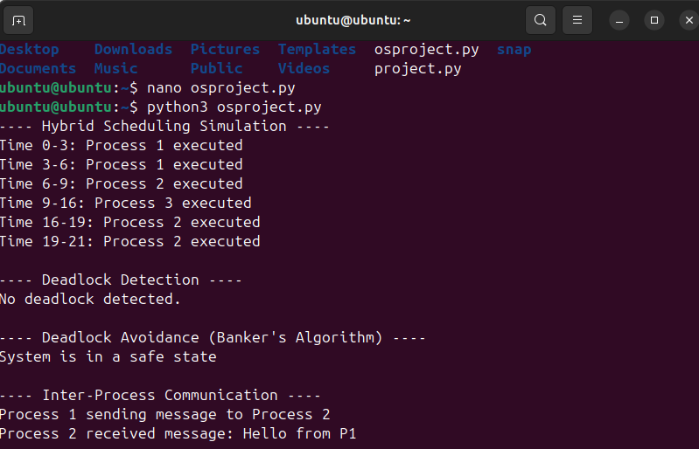
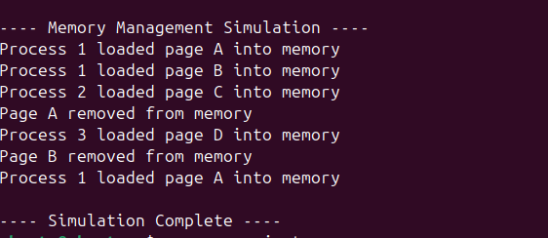

Conclusion:
This simulation project helped us understand how core operating system concepts work together in managing multiple processes. By combining hybrid CPU scheduling, deadlock detection and avoidance, IPC, and memory management, we created a simple yet effective model of a multitasking OS. The project not only demonstrated theoretical knowledge in action but also improved our skills in designing secure, efficient, and fair system behavior under different conditions.

